**COURSE : INFO 5502 ASSIGNMENT-6 STUDENTID:11442777**

**1.1 Complete the function one_resampled_mean below. It should take in an original table data, with a column Score, and return the mean score of one resampling from data.**

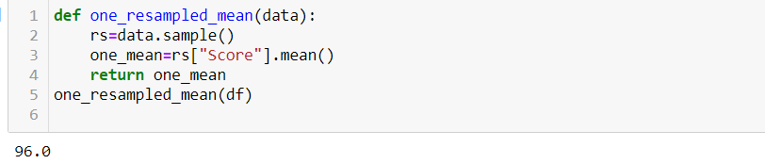

#### 1.2 Complete the function bootstrap_scoresbelow. It should take no arguments. It should simulate drawing 5000 resamples from restaurant_sampleand compute the mean restaurant score in each resample. It should return an array of those 5000 resampled means.[¶](http://localhost:8888/notebooks/Downloads/5502%20assign_6/Nerella%20assign_6.ipynb#1.2-Complete-the-function-bootstrap_scoresbelow.-It-should-take-no-arguments.-It-should-simulate-drawing-5000-resamples-from-restaurant_sampleand-compute-the-mean-restaurant-score-in-each-resample.-It-should-return-an-array-of-those-5000-resampled-means.)

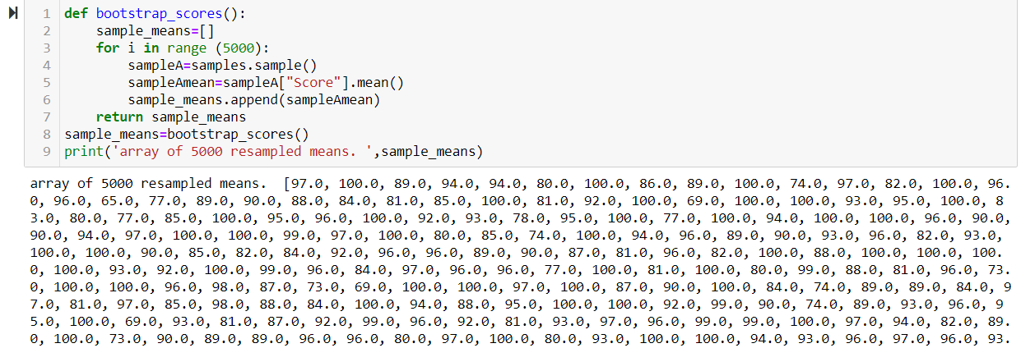

#### 1.3Compute a 95 percent confidence interval for the average restaurant score using the array resampled_means.

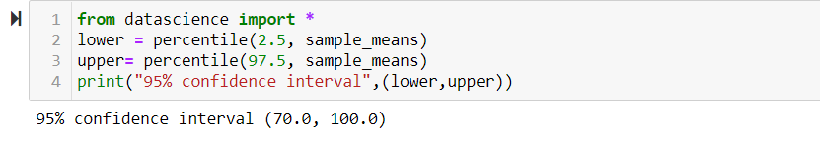

**1.4 What distribution is the histogram between question 2 and 3 displaying (that is, what data are plotted), and why does it have that shape?**

In [59]:

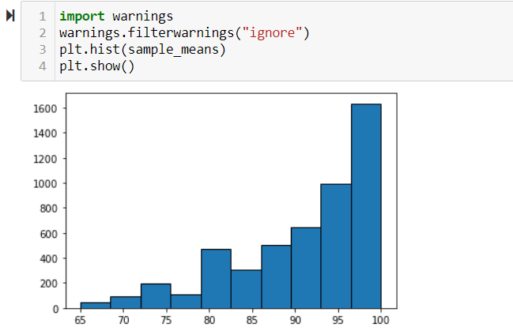

#### 1.6 Without referencing the array resampled_means or performing any new simulations, calculate an interval around the sample_mean that covers approximately 95% of the numbers in the resampled means array. This confidence interval should look very similar to the one you computed in Question 3.

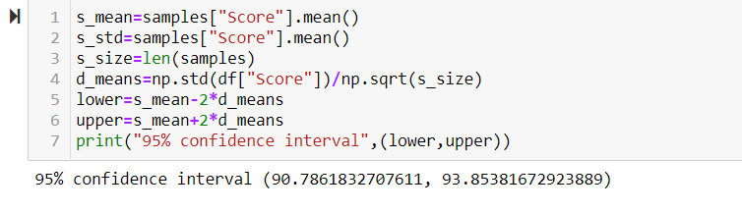

#### 2.1 Define the function one_statistic_prop_headswhich should return exactly one simulated statistic of the proportion of heads from ncoinflips.

#### 

#### 

**2.3 Write a function called empirical_sample_mean sd that takes a sample size n as its argument. The function should simulate 500 samples with replacement of size n from the flight delays dataset, and it should return the standard deviation of the means of those 500 samples.¶**

In [95]:

#### 

#### 2.4 write a function called predict_sample_mean sd to find the predicted value of the standard deviation of means according to the relationship between the standard deviation of the sample mean and sample size that is discussed in the textbook.

#### 